INTER-BRANCH FINANCING COLLECTION

Screen Shots:
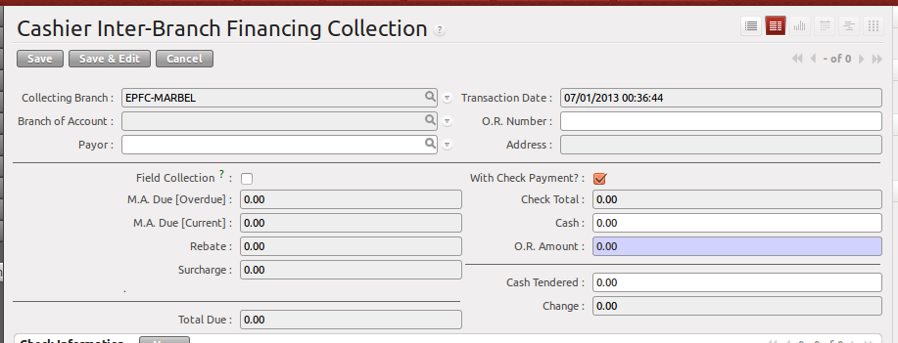
The difference between Financing Collection and Inter-Branh Financing Collection is that after you select the payor, it will reflect the Branch of Account.

After payor is filled-up, it will automatically compute the due of the client.

Sample Illustration how will the Total Due be computed.

Due Day of Client : Every 1st of the month
Today is : July 2, 2013

Payment Schedule :
Month MA Due Surcharge Rebate
June 1, 2013 - 1,500.00 45.00
July 1, 2013 - 2,000.00 under grace period
August 1, 2013 - 2,000.00 200.00
Sept 1, 2013 - 2,000.00 200.00

Computation :
M.A. Overdue - 3,500.00 (June and July)
M.A. Current - 2,000.00 (August)
Rebate - 200.00 (August)
Surcharge - 45.00 (June)

Check Information
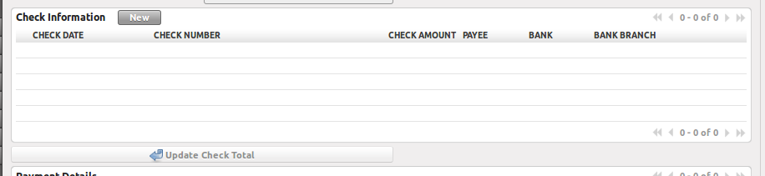
    - This will only appear if “With Check Payment” is checked.

Step 1 → Click New Button
Step 2 → Input check Details
Step 3 → Click Save Icon (diskette icon)
Step 4 → Click “Update Check Total”

Payment Details
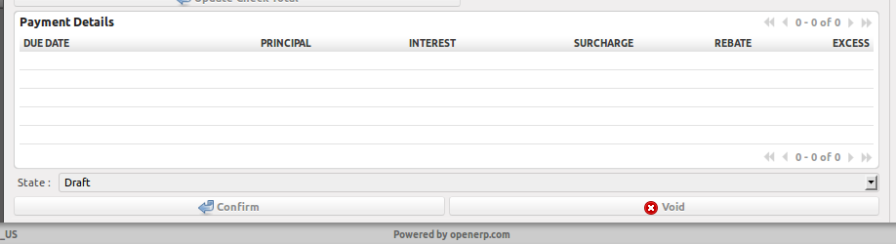
This will be automatically computed by the system.

Order of payment Application:
            - Maturity Surcharge
            - Surcharge
            - Principal
            - Excess Payment

Buttons
Confirm Button
      - Applies the breakdown to Payment Schedule
      - Generates Journal Entry
      - Changes record state to “Confirmed”
      - Updates the ledger of the client.

Void Button
- Voids the OR transaction.
- If the state of the record is not draft, it will remove the entries in the Loan Ledger. And will also void the Journal Entries of that certain document.

Validations:
    - only the OR's encoded by the branch can be viewed by the user.
    - No rebate if “Field Collection” is checked.
    - O.R. Amount is the sum of Check Total and Cash.

